Setting up Outlook
Culhane Meadows Hosted Exchange Server

Note: These instructions all assume you already have at least one account set up in Microsoft Outlook and that you would like not only your existing account, but also your new Culhane Meadows account to show up in Outlook in the same profile when you open Outlook.
A. If you are using Outlook 2007, press the control key and then click here.
B. If you are using Outlooks 2010 or 2013, press the control key and then click here.
To create a profile in Outlook 2007:
Tip: During the following procedures, if you see a popup window that asks you to log in, click Cancel. You may get an error message or another login request, but just click Cancel again.
Make sure Outlook is CLOSED before you begin.
- Go to Start > Control Panel > Mail.
***If you cannot locate the Mail icon within your Windows Control Panel, try the following steps:
  - To the left of the Windows Control Panel, but in the same window, select Classic View.
  - If Mail still does not appear as an individual icon, look for it under Show 32-bit Control Panel Items.
  - If you are in Windows 7, you may have to change the upper right hand selection that say “View By” from “Category” to View By “Large Icons.” Once you switch to Large Icons, you should now see a “Mail (32-bit)” icon.
- Click the Show Profiles button.
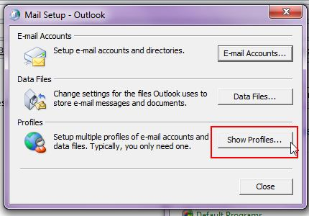
- Click on the Profile Name in the list that matches the one at the bottom beneath the “Always use this profile” and then click Properties.
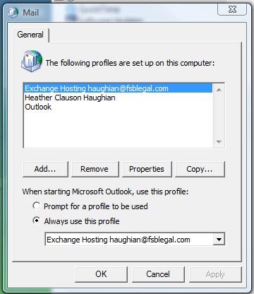
These two should match

- Click on “Email Accounts” to open Outlook Account Settings:

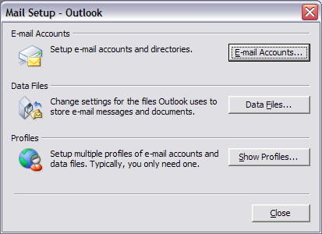

- Click “New” to set up a new account

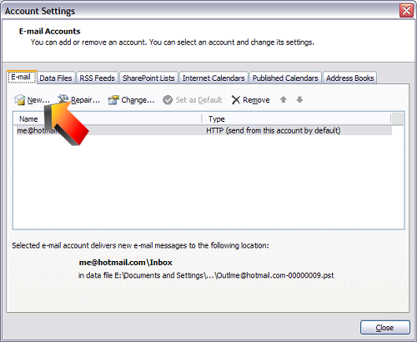
- You now need to select Microsoft Exchange, POP3, IMAP or HTTP and click Next.

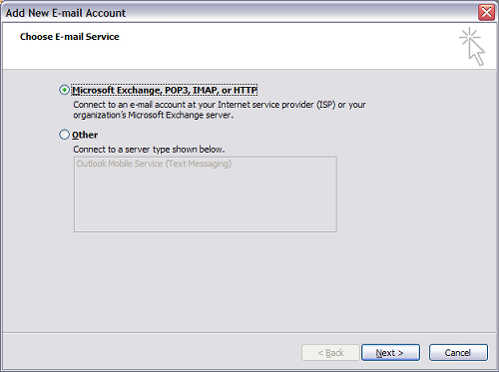

- Select Manually configure server settings or additional server types and click Next:
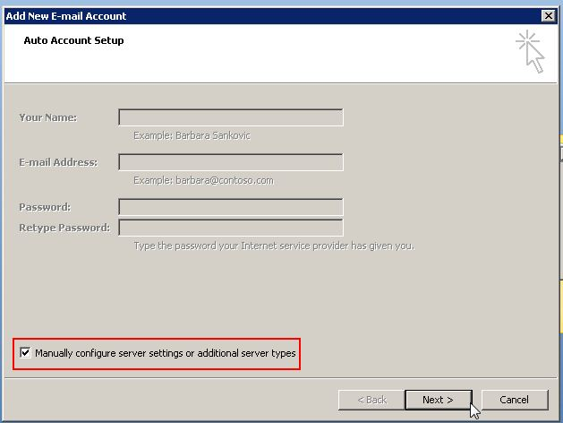
- Select Microsoft Exchange and click Next:
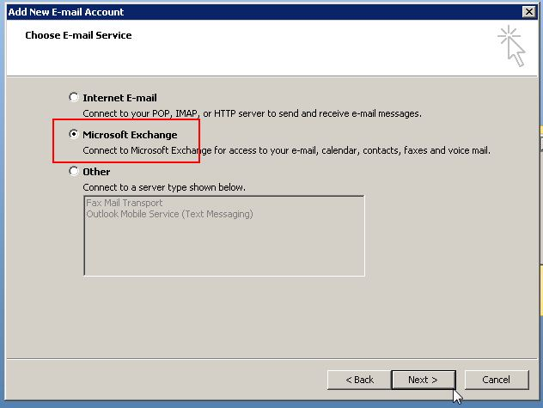

- Enter your Exchange server settings and click More Settings:
  - Microsoft Exchange Server: Type in “west.exch025.serverdata.net”
  - Use Cached Exchange Mode: Yes.
  - Username: Full email address.

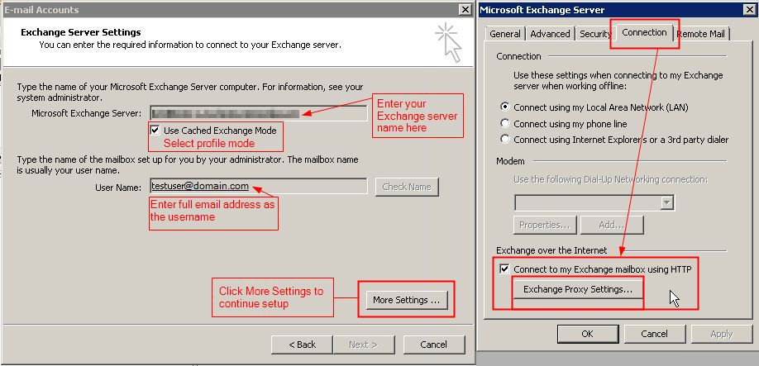
Note: You can ignore the password prompt at this point of setup. If you get an error message or additional login request, click Cancel again.
- Navigate to Connection tab, select the checkbox Connect to Microsoft Exchange using HTTP and then click Exchange Proxy Settings.
- On Exchange proxy settings page (see screenshot below) specify the following:
  - Use this URL to connect to my proxy server for Exchange: Type in: west.exch025.serverdata.net
  - Connect using SSL only: Yes.
  - On fast networks, connect using HTTP first, then connect using TCP/IP: Yes.
  - On slow networks, connect using HTTP first, then connect using TCP/IP: Yes.
  - Use this authentication when connecting to my proxy server for Exchange: Select, “Basic Authentication”
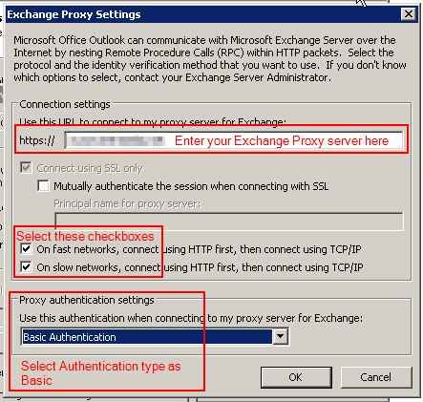
- Click OK > Apply > OK > Next > Finish. If you are prompted for the password at this step you can enter it.
- Start Outlook in this profile.

To create a profile in Outlook 2010/2013:
Tip: During the following procedures, if you see a popup window that asks you to log in, click Cancel. You may get an error message or another login request, but just click Cancel again.
Make sure Outlook is CLOSED before you begin.
- Go to your Outlook mail settings from Start > Control Panel > Mail > Show Profiles
***If you cannot locate the Mail icon within your Windows Control Panel, try the following steps:
  - To the left of the Windows Control Panel, but in the same window, select Classic View.
  - If Mail still does not appear as an individual icon, look for it under View 32-bit Control Panel Items.
  - If you are in Windows 7, you may have to change the upper right hand selection that say “View By” from “Category” to View By “Large Icons.” Once you switch to Large Icons, you should now see a “Mail (32-bit)” icon.

- Click on the Profile Name in the list that matches the one at the bottom beneath the “Always use this profile” and then click Properties.
.
.
These two should match

- When the Mail Setup box pops up, click on the “E-mail Accounts” tab
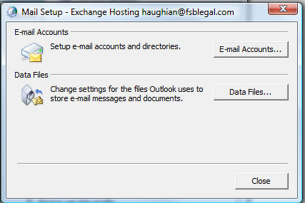
- On the E-mail Accounts, make sure the “E-mail” tab is selected (it should be there by default), and then click on the “New” button.
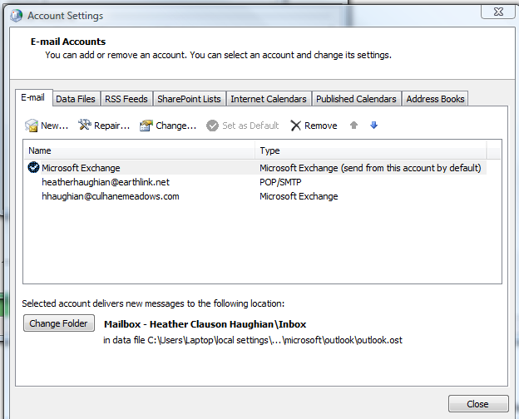
Click here
This should not show up yet for you as mine is already set up.
- On the Auto Account Setup page, select Manually configure server settings or additional server types and then click Next. .
- On the Choose Service page, select Microsoft Exchange or compatible service and click Next.
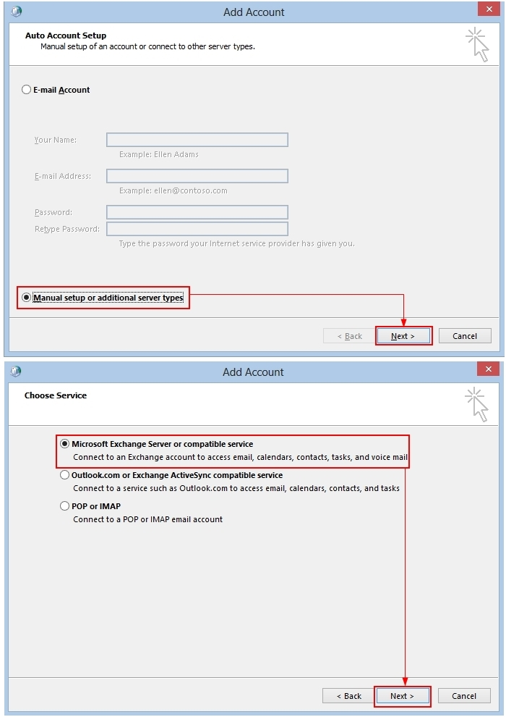
.
- On the Server Settings page:
- Specify your Server as “west.exch025.serverdata.net”
- Type your Exchange Mailbox Username (use your email address).
- Click the More Settings button and switch to Connection tab.
.
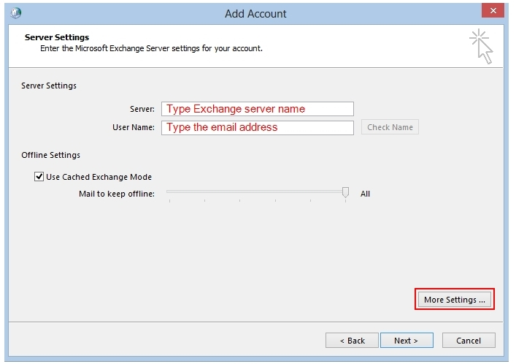
..
west.exch025.serverdata.net

- From the Connection tab, select the Connect to Microsoft Exchange using HTTP option at the bottom underneath “Outlook Anywhere” and click the Exchange Proxy Settings button.
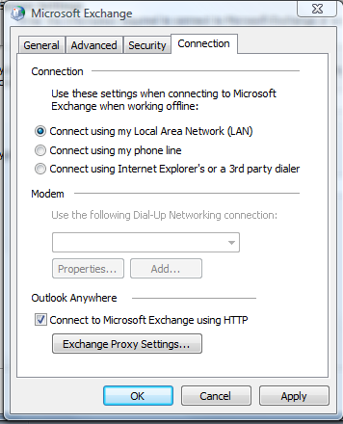
-Specify Exchange proxy settings.

Type the URL for your proxy server in the “Use this URL to connect to my proxy server for Exchange” field. Type in: west.exch025.serverdata.net
-Make sure that both the options On fast networks and On slow networks are checked.
-In the Proxy authentication settings box, choose Basic Authentication.
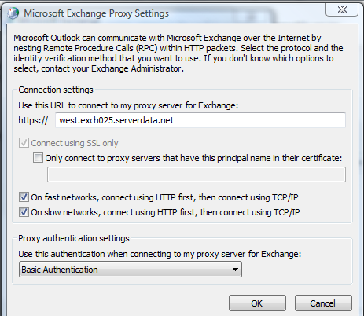
.
.
- Click OK, then Apply, then OK to return to the Add New Account window. Click Check Name.
If you have set everything up properly, you will see a window requesting authentication.
- Enter the complete primary email address as the username, and enter the password for the mailbox.
If you have entered the username and password correctly, the username will now be underlined, and the entry in the Microsoft Exchange Server field will also be underlined.
- Click Next, then Finish, then OK to save changes.
- Start Outlook and log in, using the same credentials as in step 10.

